Netflix Dashboard

Introduction:
Netflix is an American streaming service that launched on august of 29th of 1997 and has grown to become one of the most popular media and streaming platforms in the world. They offer a multitude of films and television series, with over 8000 movies/ tv shows available on their platform. In just 12 years they have manged to build a yearly revenue of over 25 billion and as of the year 2022 they have almost 214 million subscribers (Netflix - Wikipedia, 2022).

Data
This dataset contains listing of all the movies and tv shows currently available on Netflix , along with other details such cast information, directors, the ratings of each movie along with the yearly releases of each tv show and movie and their duration. The source to the dataset can found here: https://www.kaggle.com/datasets/shivamb/netflix-shows. The data dictionary below details what variables are present in the dataset.
Name | Description | Domain
Show_id | Unique ID for every movie/ Tv show | String
Type | Identyfier- A movie or Tv show | String
Title | Title of the Movie/ Tv show | String
Director | Director of the movie | String
Cast | Actors involved in the movie/ show | String
Country | Country where the movie/ tv show was made | Geo spatial
Date added | Date the tv show / movie was added onto Netflix | Integer
Release year | Actual release year of the movie/ show | Integer
Rating | age rating of the tv show /movie | String
Duration | Total duration- in minutes or number of seasons | String
Listed in | The type of genre the show falls under | String
Description | The summary description | String
Netflix_titles.csv | The number of shows/movies Netflix has | Integer

Persona
Netflix as a streaming service produces a lot of content using this dataset we can examine where the company seems to focus their efforts along with the kind of content that is present on their platform. Looking from the perspective of a Netflix executive questions the following questions to be asked:
Does Netflix focus more on the production of Tv shows or its movies and how does this differ across countries?
What is the most common age rating for all Netflix content and how does this change across countries?

Requirements
- To answer question one the user will need to visualise the variables country followed by titles. Other variables to use would be the year and type
- Use the map plot of the country/ filtered by type
- Filtered by Netflix titles using colour to denote the number of titles
- Stacked horizontal bar plot with each colour representing a different country, separated by type and filtered out by year.

- To answer question 2 the user will need to focus on using the following variables, country and rating in other to compare.
- Tree map filtered by rating and marked by country
- Packed bubble chart with size indicating the amount of tv shows/ movies that have been filtered by rating and segregated by type.

Netflix Dashboard

Paper Landscape
Goal: The goal of this dashboard is to see what kind of content is available in different countries and determine Netflix has more of a focus on tv show or movies and how this may have changed over the years along with which countries produce the most content.
Q1. Does Netflix focus more on the production of Tv shows or its movies and how does this differ across countries?
Q2. What is the most common age rating for all Netflix content and how does this change across countries?

The map encoding helps to visualise the distribution of Netflix shows and movies across countries according to colour and density (Q1)
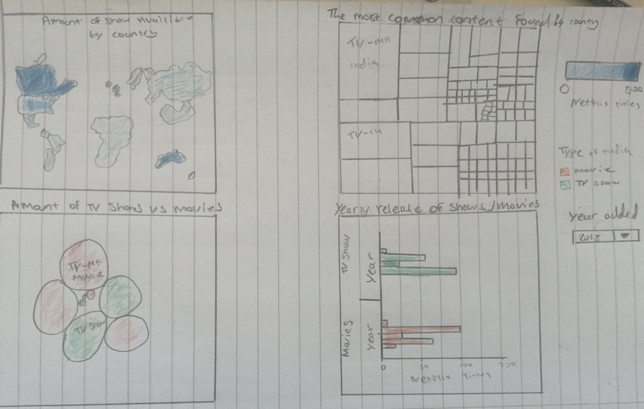
Global filters that detail what the colour gradients signify along with a widget that filters the years
Tree map encoding used to visualise what type of content is produced regarding their rating. With size indicating the amount of content produce with similar rating in each country.
Horizontal bar chart filtered using year variable to examine what years were the most show/movies produced and released on to Netflix (q1)
Figure 1 Prototype design implementation
Bubble chart encodes in size to compare the amount of shows present in the Netflix database compared movies, with shows and movies being separated by colour and filtered by the age rating so that the user may also see the most common age rating of Netflix media. (q1 and q2)

Key containing the three different filters for year, country and new filter type along with colour scale to indicate amount of titles in each country. Q1 q2
Bubble chart used to compare amount of tv shows produced compared to movies (q2 and q1)

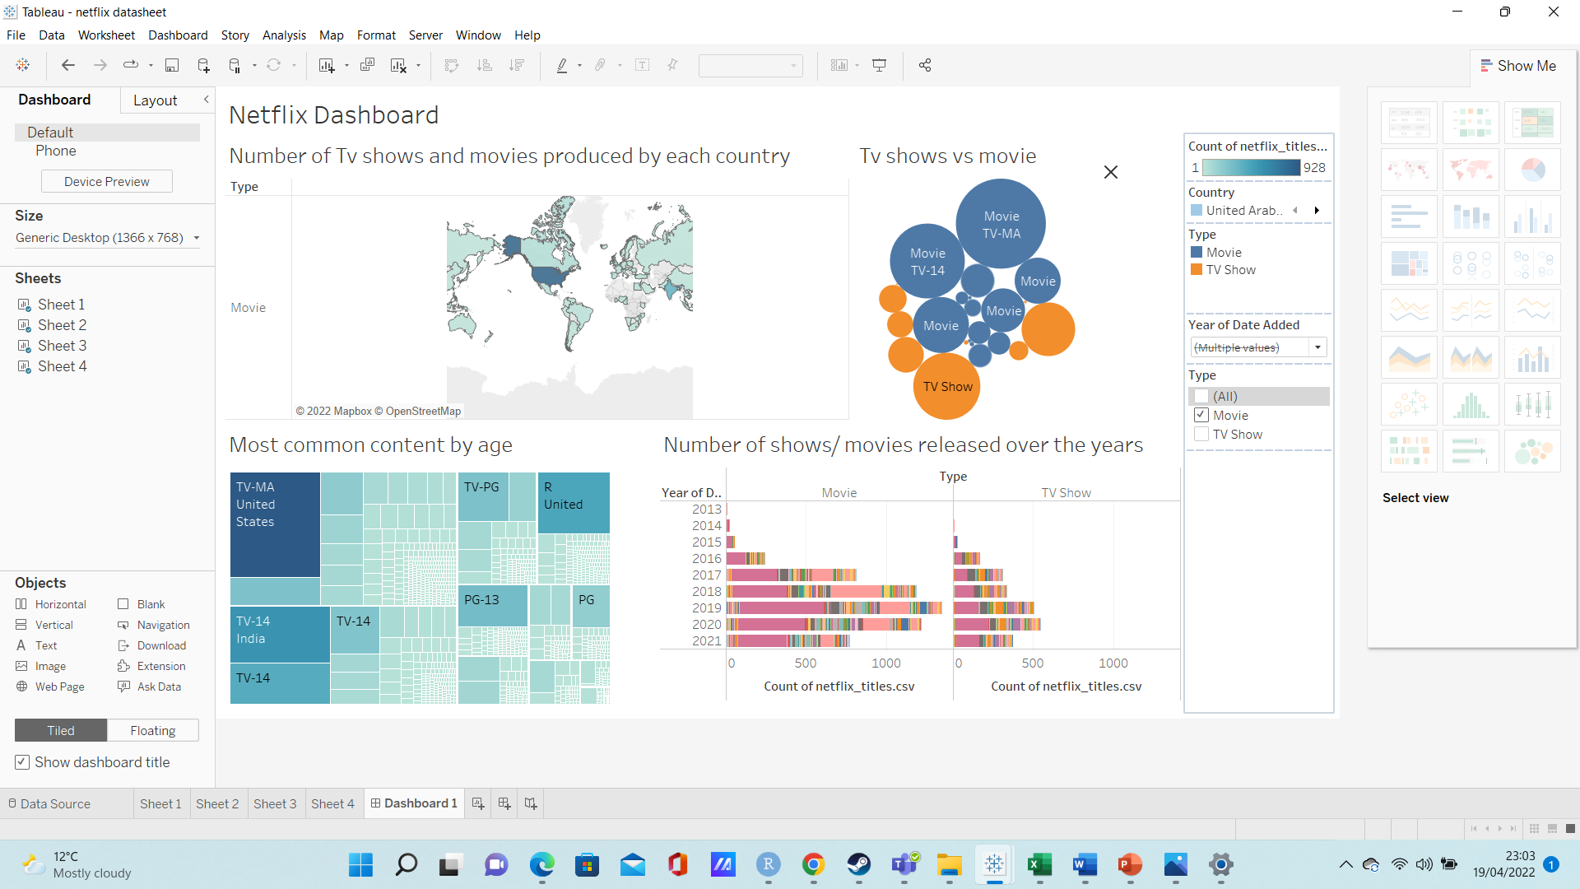
Horizontal stacked bar chart showing all the Netflix movies and shows released by year. There is colour filter on the chart to signify each country. Easy to compare between the movies and shows produced over the years. (q1)
Tree map used to highlight the amount shows produced that contain specific age ratings in different countries q2
Figure 2 final design implementation

Result
The user should be able to see where Netflix focuses are in regards to their shows and movies along with what countries produces the most content and what years Netflix was the most active when produce said content.

Map visualising which countries produce the most show/ movies (q1)

Implementation
Sheet 1
A bubble graph is utilized with sum of Netflix titles being marked with sized. Each of the circles are labelled displaying both the rating and the type of content they represent. Type is also encoded in colour to differentiate between the amount of movie and tv show content available with distinct colours blue and orange being used to identify what each circle represents. Blue representing all the movie content and orange representing all the tv show content.
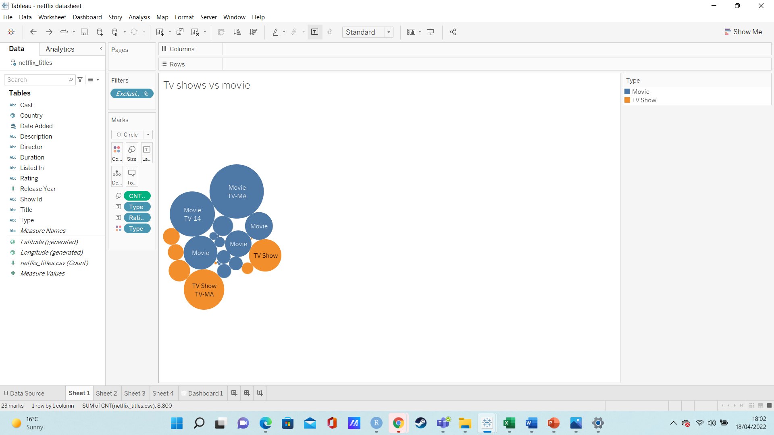
Figure 3 bubble graph visualisation. Tv shows vs movies
Sheet 2
The second representation is a map which highlights the number of movies and tv shows produced in each country. Dragging the country tab to the centre will lead cause tableau to assign a value for latitude and longitude for each country. Adding the Type variable to the row variable will generate two maps, one that shows the number of movies produced by country and another that shows the number of tv shows produce by country. A new filter tab was added that will allow the user to switch between map views, showing either number of movies produced by each country, or the number of shows produced by each country.
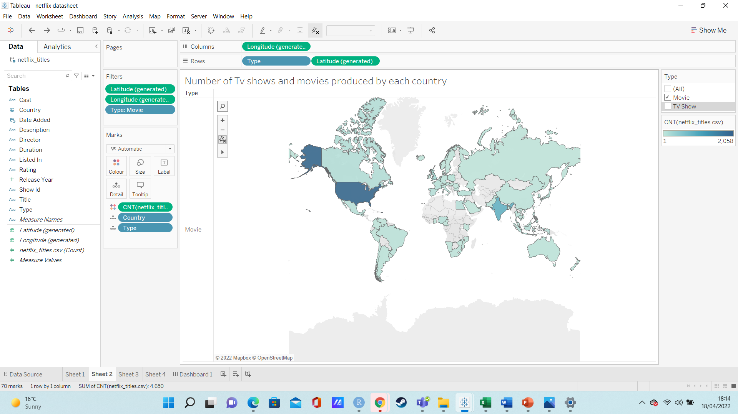
Figure 4 map visualisation of movies and shows
Sheet 3
The third representation is a Tree map with each square representing a different country and detailing the age rating of the content commonly produced in those countries. The sum of Netflix titles is marked by colour gradient with the deeper blue colouring indicating a large amount of show/movie produced by a particular country. The Netflix_ titles is also used as a size indicator so larger squares also indicate the amount of each age rated content by country .
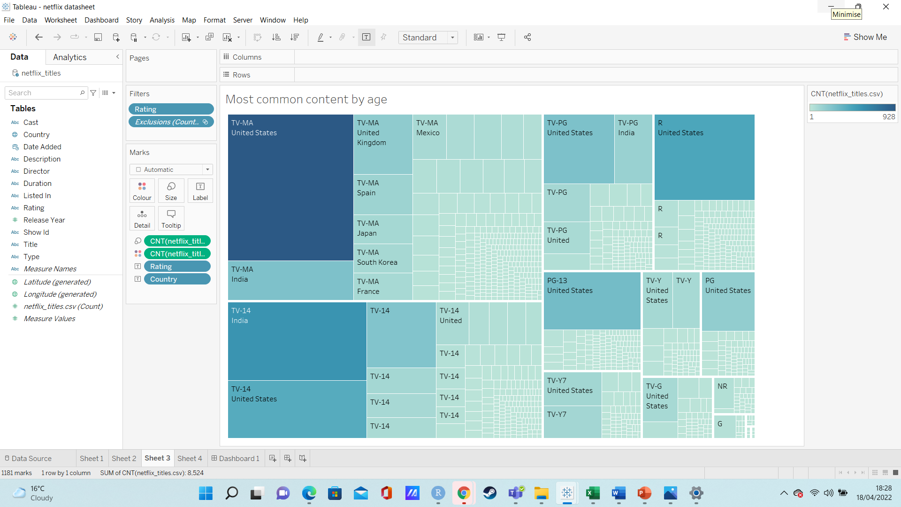
Figure 5 Tree map visualisation of the most common rated content by country
Sheet 4
The final representation is a horizontal stacked bar chart with the year variable placed on the row section and the Netflix titles being placed in the columns. Dragging the Type variable to the column section produces two bar charts, one for movies and another for shows. The country variable is added as a colour filter so that hovering over with the mouse will show which country has produced a movie or show in the recent years.
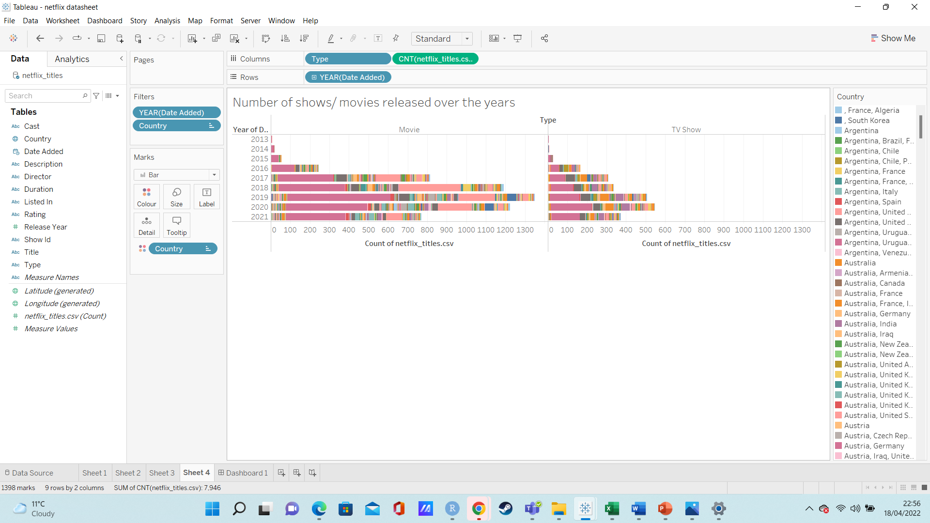
Figure 6 stacked bar chart visualisation of movies released

Walkthrough
To answer Q1 using fig 4 the map visualisation gives a clear picture of which country produces the most movies along with which countries produces the most tv shows. From the visualisation it was clear to see the country that produced the most movies was United states by a wide margin followed by India then the UK and lastly Canada. Using the key to switch the view to tv shows also show a similar trend with the countries that produced the most movies also produce the most tv series. Another additional insight is that by hovering over the countries it clear to see that far more movies are produce when compared to movies with America having produced a total of 2058 movies compared to 760 tv series. This seemed to be the norm for countries like India where 893 movies were produced compared to 79 tv shows and same can be seen with Canada where 122 movies produced and only 59 tv shows were produced. The only outlier being the UK as the country appears to produce more tv shows than movies. Figure 3 also gives the user a good indication that movies are the focus with the larger blue circles indicating a higher number of movies released compared to their tv shows.
Additionally with figure 6 using the stacked bar chart and filtering it by type reveals how many shows Netflix have released over the years. Looking at the visualisation it is clear to see that from the years of 2013 to 2019 Netflix’s production of movies has increased over the years and when compared to the amount of tv shows being produced. We can see that over those four years Netflix have had a greater focus on producing movies then tv shows. Furthermore, looking at the bar chart from the years 2020 and 2021 Netflix have produced slightly fewer movies likely due to real world issue caused by the current pandemic (Sherman, 2020). But still manage to exceed the number of tv shows. Ultimately, from the data presented it appears Netflix produces most of their content in America.
In order to answer the second question regarding what’s the most common age rating for Netflix’s shows and movies is, using fig 3 a bubble chart visualisation was used. As it encodes in size the larger circles reveal that there is large amount of Netflix movies and tv shows rated Tv-MA closely followed by the tv-14 rating. Figure 5 provides even more detail as it reveals what kind of content is available in other countries and hovering over the darker hued squares on tree map reveals that America produces the highest amount of tv-ma content that’s available on Netflix followed by India and then the UK. And this trend continues as America produces most of the rated content with only exception being tv-14 content which is mainly produced by India.

Discussion
Visual analytics is defined as the creation tools and techniques in order to help people synthesise and derive insight from massive, dynamic and conflicting data (Keim, Kohlhammer, Ellis and Mansmann, 2010).
I believe that in using tableau I have been able to successfully answer both questions through the implementation of my dashboard. By observing the dashboard, it possible to see which countries have produced the most content that is available on Netflix and answer whether Netflix prioritises the production of their movies over their Tv shows. We are also able to see what’s the most common age rating for all the company’s content. With the tree map show casing the typical age rating for all the content produced in each country. The implementation of these views I found to be relatively easy, with few issues in creating the graphs and getting it to fit the dashboard. The drag and drop functionalities in tableau make it very easy to create an interactive visualisation. During the creation of my dashboard, I considered adding a fifth view being a bar chart to help provide an even clearer picture to the user on the most common age rating for all of Netflix’s content. However, ultimately decided against this as the dashboard became far too cluttered and per the assignment brief the user had to be able to view the data without having to scroll up and down the dashboard. A second dashboard would have to be created for all the data to fit cleanly as per the assignment only one dashboard could be created. There was also another issue with one of the views specifically view 4 where not all the years were able to fit on the y axis. Originally the stacked bar chart went through years 2008-2021, I had to create a filter for the years excluding the years 2008-2012 to minimise the amount of scrolling. Similarly, issues also arose when I used the map chart as filtering the map through type generated two whole maps which led to a lot of scrolling so a filter was needed so that the dashboard would only display a single map and if the user wanted to view which countries produce the most tv shows or movies they could click on the filter box and have one or the other showing. In terms of my own personal learning, I feel a lot more confident in using tableau to create visualisations and creating filters to better fit my dashboard. Keeping in mind to minimise mistakes by not overusing colour unless necessary and trying to arrange the data so that it fits neatly onto the dashboard so that it is understandable (Few,2006). This project also had considering the many techniques used in tableau to best represent the data in my set and how I could turn the raw data into something that people could gain insight form to best answer the questions I had set out (Spence,2014).

References
En.wikipedia.org. 2022. Netflix - Wikipedia. [online] Available at: <https://en.wikipedia.org/wiki/Netflix> [Accessed 19 April 2022].
Few, S., 2006. Information dashboard design. Beijing: O'Reilly.
Keim, D., Kohlhammer, J., Ellis, G. and Mansmann, F., 2010. Mastering the Information Age Solving Problems with Visual Analytics. Eurographics Association.
Sherman, N., 2020. Five ways the virus has changed Netflix. [online] BBC News. Available at: <https://www.bbc.co.uk/news/business-54623959> [Accessed 27 April 2022].
Spence, R 2014, Information Visualization : An Introduction, Springer International Publishing AG, Cham. Available from: ProQuest Ebook Central. [21 April 2022].
www.javatpoint.com. 2022. Advantages of Tableau | Disadvantages of Tableau - javatpoint. [online] Available at: <https://www.javatpoint.com/advantages-and-disadvantages-of-tableau> [Accessed 20 April 2022].
Xenonstack.com. 2022. 10 Best Practices for Data Visualization That You Should Know. [online] Available at: <https://www.xenonstack.com/blog/best-practices-data-visualization> [Accessed 23 April 2022].

